Dear Ladies and Gentlemen,
I was a member of delegation organized by the Marshal of the Warmia and Mazury Voivodeship on 10-13 September 2014. Our task was, among other things, to assess the needs and the opportunities to organize help for health care institutions in Ukraine, especially military hospitals healing wounded soldiers and sometimes also civilians.
Community hospitals in Ukraine are quite poorly equipped, but the state of the military health care is tragic. For example, a general hospital does not posses a functioning X-ray machine.
If anyone of you have at her/his disposal used but functioning medical equipment, I would be very grateful if you could provide me with the information concerning the equipment with a brief description and photo to my e-mail: r.lewandowski@pfsz.org. After gathering the information, I will be in contact with you concerning the possibility of transporting and installing the stuff in Ukraine. If someone would be capable to transport the equipment by herself/himself, I can offer the addresses for delivery. They need everything: audiometers (soldiers stunned after explosions), cardiac monitors, portable or stationary ultrasound, defibrillators, laparoscope, dressings, all kind of pharmaceuticals, etc..
Please find enclosed some photos from the Military Hospital in Rivne in western Ukraine, in order to realize how the infrastructure is underinvested. The hospital has already treated hundreds of wounded soldiers. I am sorry for the poor quality of photos, but it I was taking them with my phone.

Sincerely,
Roman Lewandowski, Director of Voivodeship Rehabilitation Hospital for Children in Ameryka, Olsztyn, Poland (www.ameryka.com.pl), Member of the High Council, Polish Hospital Federation, (www.pfsz.org)

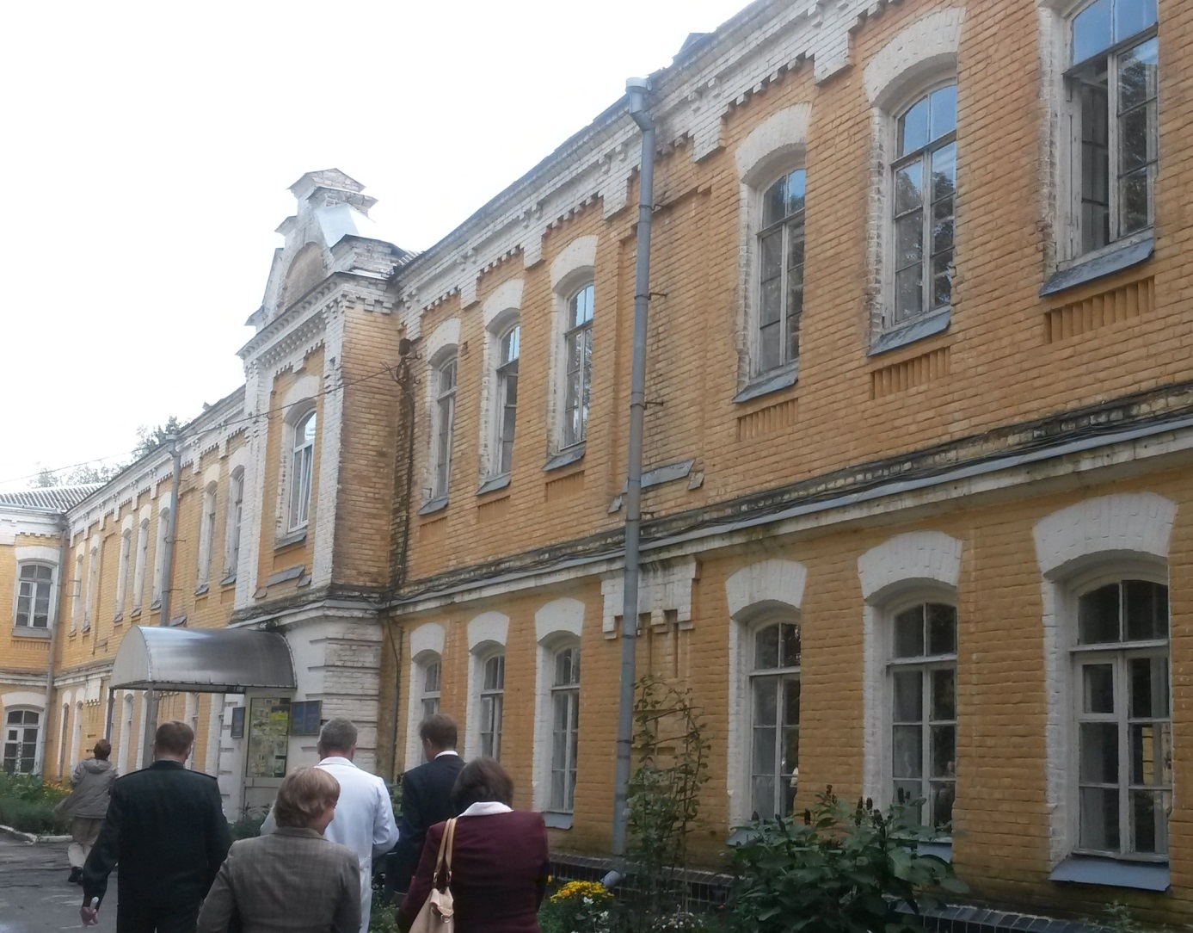
Military hospital in Rivne, Ukraine

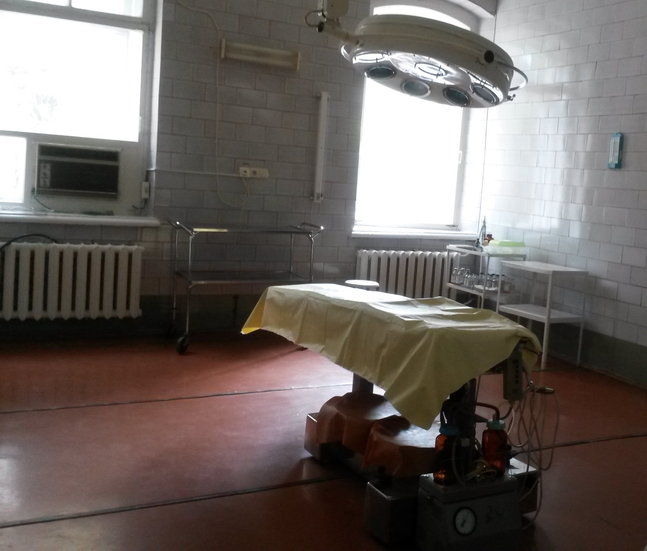
Operating theatre

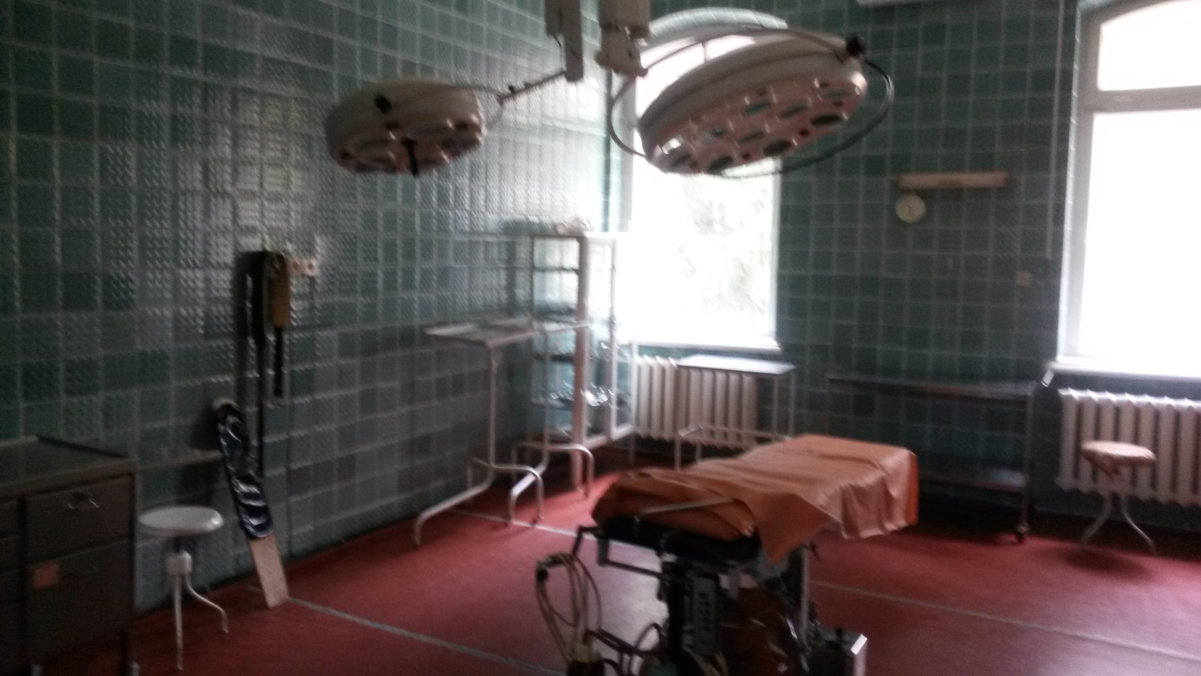
Another operating theatre

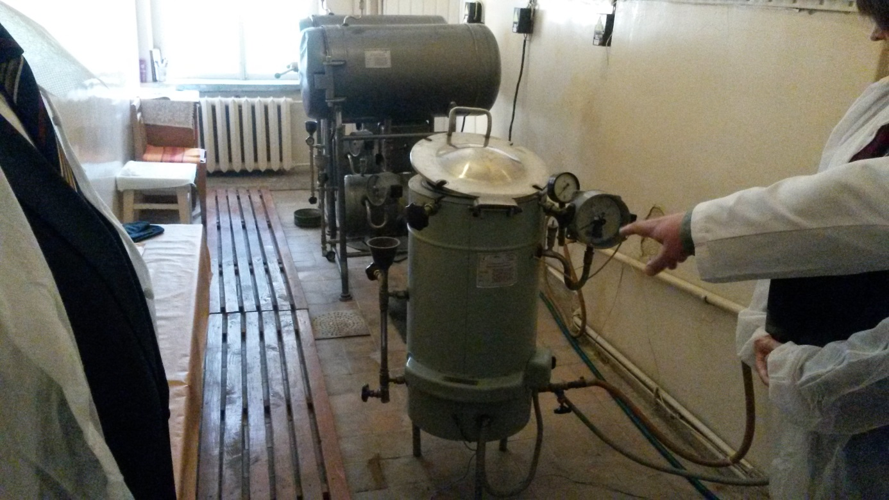
Hospital „central sterilization”

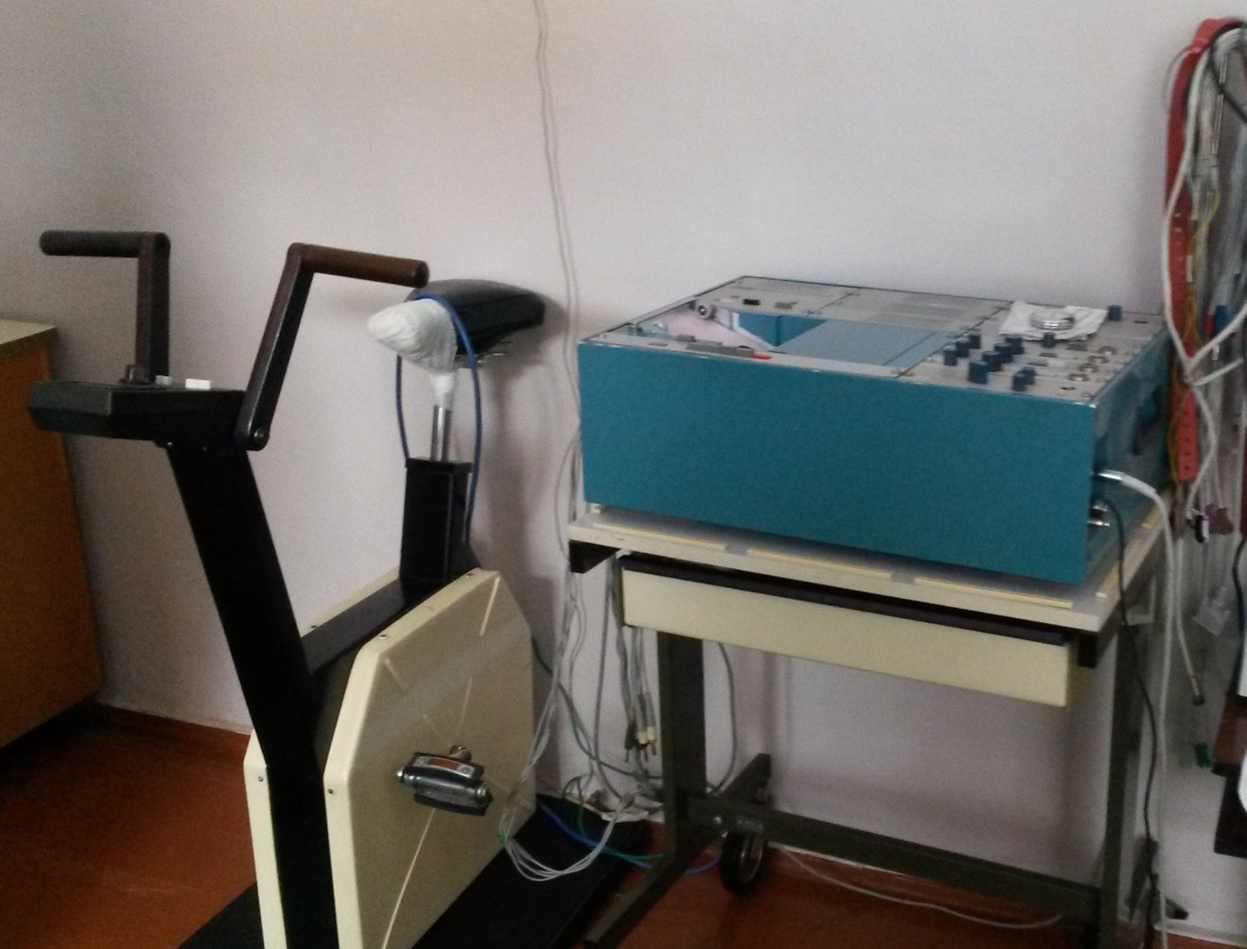
Cardiology exercise stress testing lab
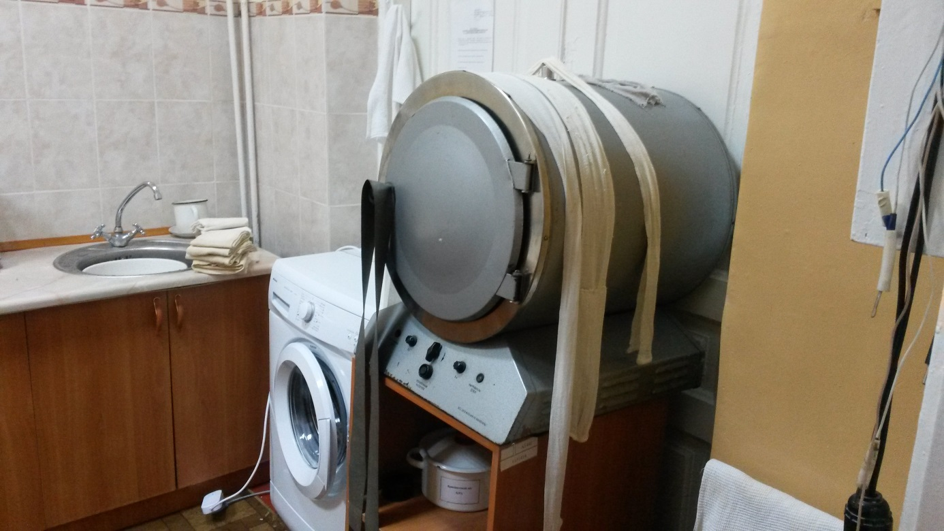
The hospital lacks disposable dressings. Dressings and bandages are washed and resterilized

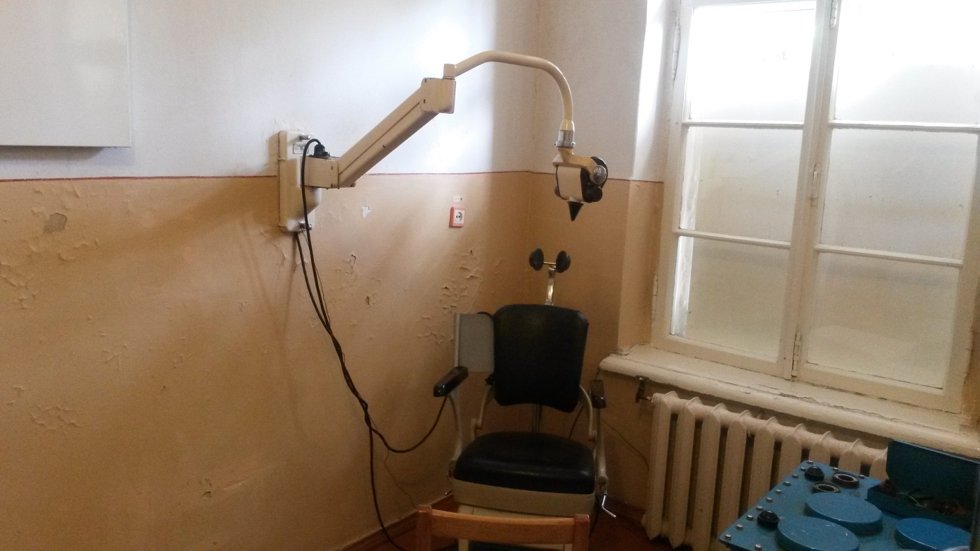
X-ray – Dentistry

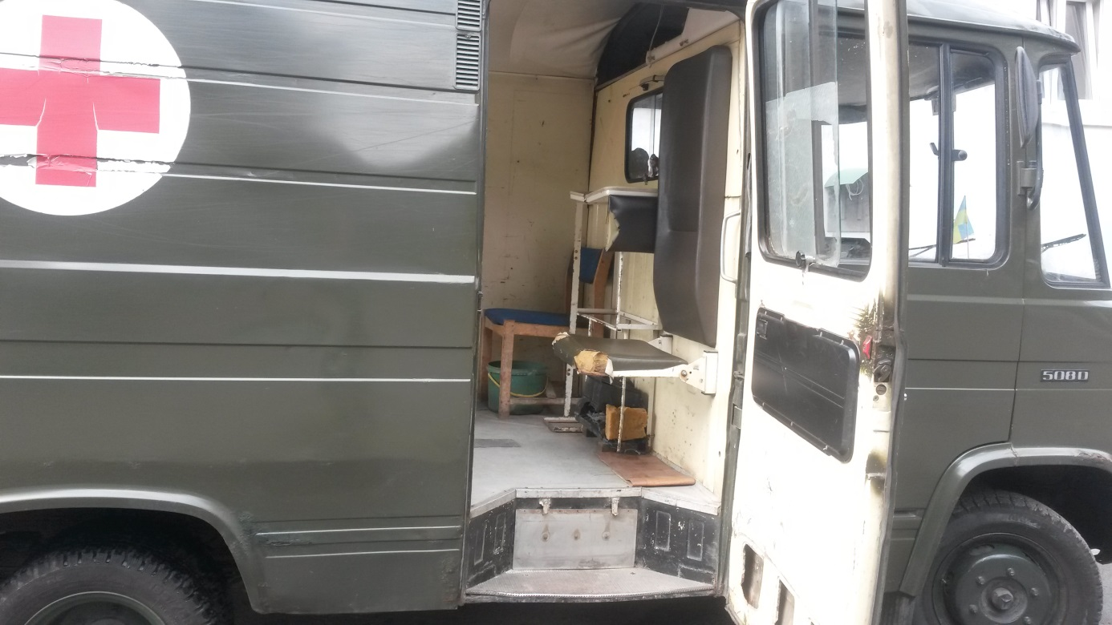
Ambulance for wounded people

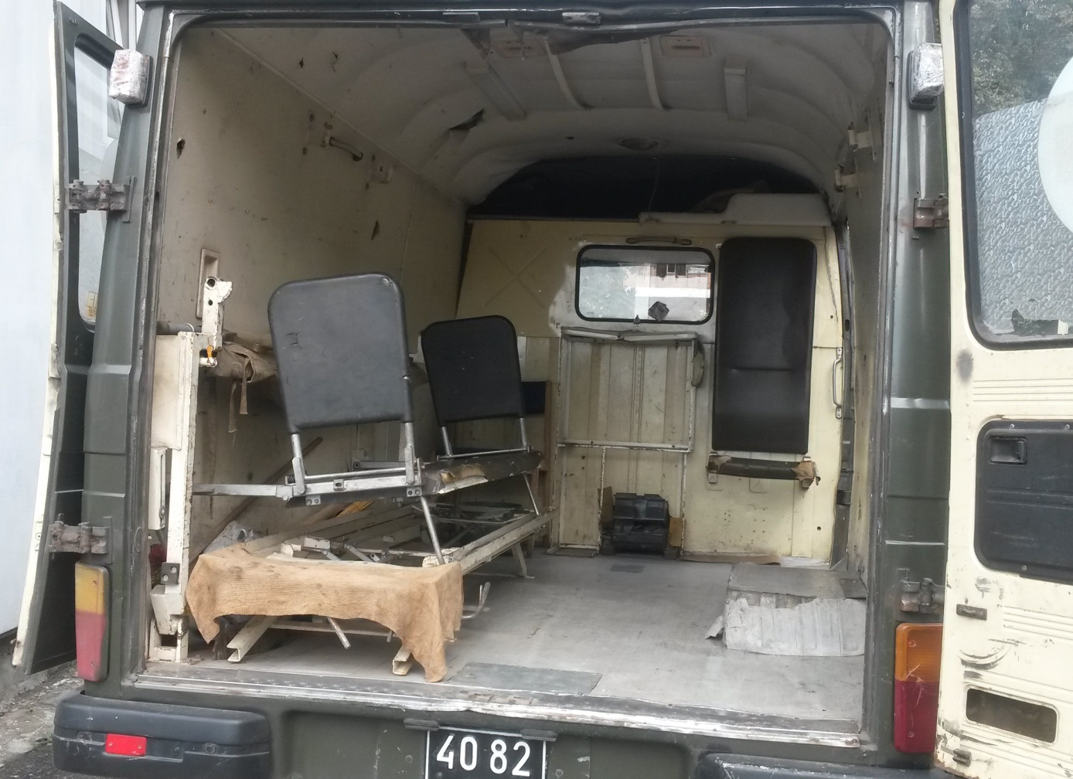
The interior of the ambulance
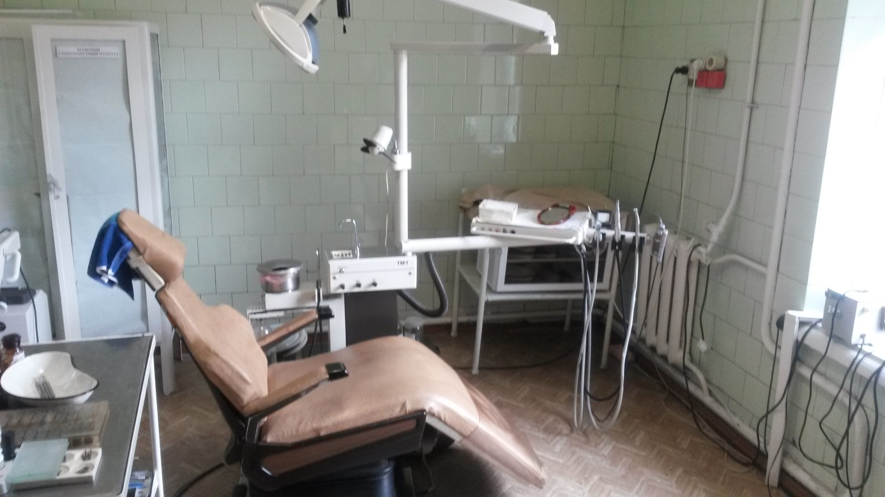
Dental clinic

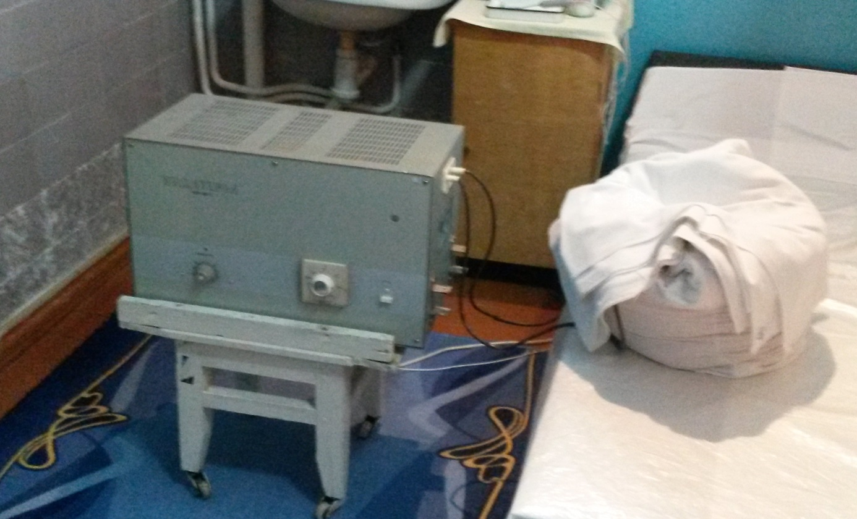
Physiotherapy

